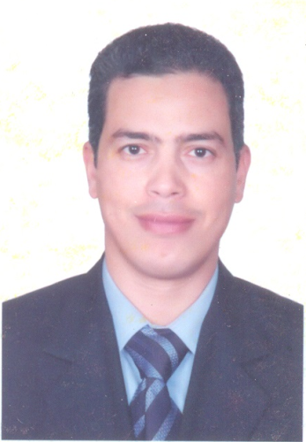
Name: Magdi Mohammad Mostafa Hasan.
Work: Assiut university – Faculty of medicine – Ophthalmology department.
Birth date: 4/9/1975.
Current Job: Assistant lecturer – Ophthalmology department.
Scientific history:
- M.B.B.ch of medicine and surgery, Sept. 1999 with (very good) degree from Assiut university.
- Master degree of Ophthalmology on 26/6/2004 with (good) degree from faculty of medicine – Assiut university.
- Finished M.D. exams on Sept. 2013 and proceeding with the thesis.
Job history:
- Internship at Faculty of medicine, Assiut university from 1/3/2000.
- Residency at Ophthalmology depart., Assiut university hospital from 1/3/2001.
- Teaching assistant at Ophthalmology depart., Assiut university hospital from 1/3/2003.
- Assistant lecturer at Ophthalmology depart., Assiut university hospital from 8/5/2013.
Marital status: Married.

